Draft Position Description
Position: | Heat Pump Installer
Reports to: | Electrical Foreman
Location: | Christchurch
Group: | Switched On Building Solutions
Direct Reports: | NIL
Values:
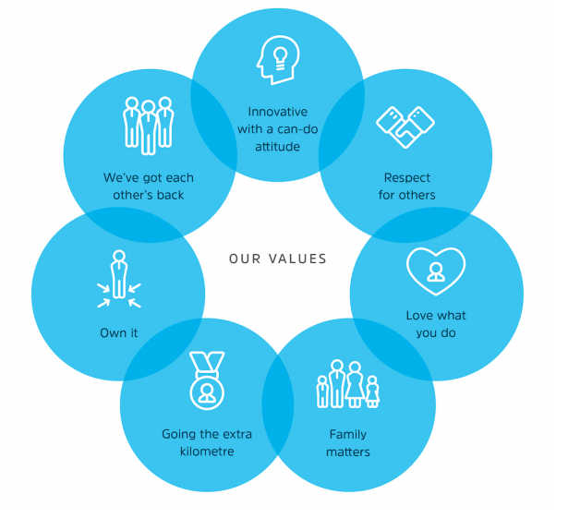

Financial Authority to Act: | NIL
Decision Authority to Act: | NIL

Position Description and KPI Acknowledgement
Your general duties include those outlined in this position description and may be reviewed and updated from time to time in consultation with you. You will also be required to undertake any other duties that are within your ability to perform, if asked to do so.

I have read, understood and agree to comply with the above position description and KPI’s.

Employee Signature: |  | Date:
Key Performance Indicators – Functional Accountability Chart
Area of Accountability | Core Responsibilities and Typical Activities | Measurement of Performance
Purpose | To provide the trade skills, knowledge, experience and competency to undertake electrical work and heat pump installations. All work must comply with the specified requirements of the customer in a safe and timely manner.
Values | - Demonstrates Switched On’ values daily and is passionate about Enhancing Environments. | - Adherence to the Switched On Values
Professional Development | - Undertakes professional development required to meet expectations of role | - Consistent with 1:1 and annual milestone achievements
Daily Operations Requirements | - Carry out all Electrical duties as required by the Manager, ensuring Quality and Compliance checks are completed  - Carry out private commercial and residential work to the minimum required KPI as per the contract | - All work completed to high standard, with no rework required  - Sufficient tools / materials available and maintained in good working order  - Maximises chargeable hours on completed projects
Heat Pump Installations | - Carry out all residential heat pump installation duties as required by the Manager, ensuring Quality and Compliance checks are completed | - All work completed to high standard, with no rework required
Administration | - Fill job and timesheets out accurately and return daily  - Ensure Purchase Orders and Job Numbers are used at all times  - Assist with any quoting requirements when requested | - You respond positively to requests for assistance in own and other areas, demonstrating adaptability and willingness  - Quotes completed and despatched within agreed timeframes
On Call Work | - Carry out rostered on-call work as required
Productivity | - Managing your day to ensure a productive and efficient operation  - Working to a tradesman like standard and ensuring Switched On meet our contractual obligations for quality and timeliness  - Responding to any work related queries in a timely and professional manner | - Jobs completed within timeframes  - Positive feedback from customers
Customer Experience | - Working on behalf of Switched On Group together with our contractors to build positive relationships in the homes & communities that we serve. | - Positive feedback from customers  - Positive feedback from subcontractors
Other Projects | - Using your Innovative can do attitude when required assist’ with additional delivery workstreams | - Projects delivered on time when asked

Health & Safety | - Champion Health and Safety to ensure the Policy and processes become part of daily practice  - All Switched On Health and Safety policies and procedures are adhered to  - Attend mandatory Health & Safety monthly Tool Box meetings. | - Health and safety priority to ensure self and others work safely.  - Demonstrates and promotes positive attitude to safety, in line with Switched On health and safety policies and procedures  - Actively seek out and pursue health and safety improvements  - Actively report Incidents and Accidents within 24 hours of occurrence  - Actively manage hazards and risks
Key Internal External Working Relationships
The role will call on strong interpersonal skills to interface with other internal departments and external stakeholders to influence quality for the customers.

Key Competencies
Skill / Technical Competencies | - Sound knowledge of NZ Electrical Codes; and Council and Heritage requirements  - Competent with installing residential heat pumps ensuring industry compliance  - Works as part of team, consulting, providing feedback, sharing knowledge and working to meet common goal  - Stamina and drive for success, the company’s success, and the opportunity for repeat business  - Excellent communication skills  - IT proficient  - Resourceful, well-organised, highly dependable, efficient and detail oriented  - Superior interpersonal skills including tactfulness, diplomacy, and persuasiveness  - Strong customer service focus  - Able to work well when under pressure of completion deadlines  - Proven time management, organisation and people management skills  - Superior interpersonal skills including tactfulness, diplomacy, and persuasiveness  - Positive attitude with a high energy level, comfortable performing multi-faceted projects in conjunction with day-to-day activities  - Creative problem-solving skills  - Valid driver’s license and good driving record  - Sound understanding of NZ Health and Safety legislation
Behaviour Competencies | Service Excellence  - Demonstrated Service Excellence Orientation  Working Together  - Contributes towards and encourages our people to think and behave in ways that meets common goal  - Has a clear understanding and supports divisional business priorities  Administrative Efficiency  - Strong written and verbal communication skills  - Accurate with strong attention to detail  - Organisational skills  - Process driven  Personal Effectiveness  - Ability to manage and motivate yourself to deliver results  - Initiative, enthusiasm and ability to work without direct supervision  - Conflict resolution and negotiation  - Well-developed and proven judgement and problem-solving skills  - Reputation for reliability and honesty  Planning and Organising  - Excellent Time management  - Able to work well when under pressure of completion deadlines  Understanding Switched On  - Understands our group of companies, our objectives, partners, customers, systems and processes and the opportunities for sales. They incorporate and understand the values of Switched On by focusing on the development of our business with capability attraction and retention from a commercial perspective

